Asia-China-Shang-Bronze-Tiger eating man-Final

Bronze Age, Shang bronze wine vessel, yu虎食人, LENGTH: 22.5CM/8.86Inches, HEIGHT: 34CM/13.39Inches' CONDITION: Rust on the body, museum quality.

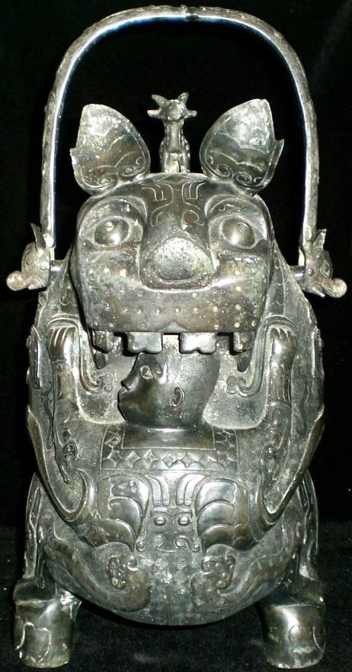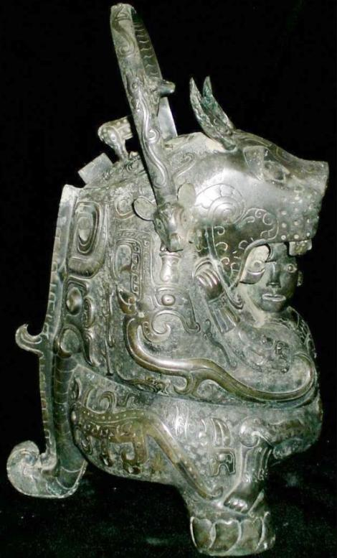

This erect standing composite bronze tiger is supported by its two rear feet and its tail. A human figure with his head in its gaping jaws and with his arms grasping its breast with his feet on its front feet is being held in place by the tiger with its front paws.

The tiger is clearly a composite of many animals. An antelope stands on its head:

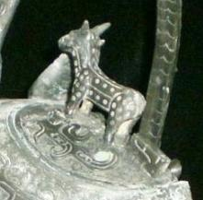

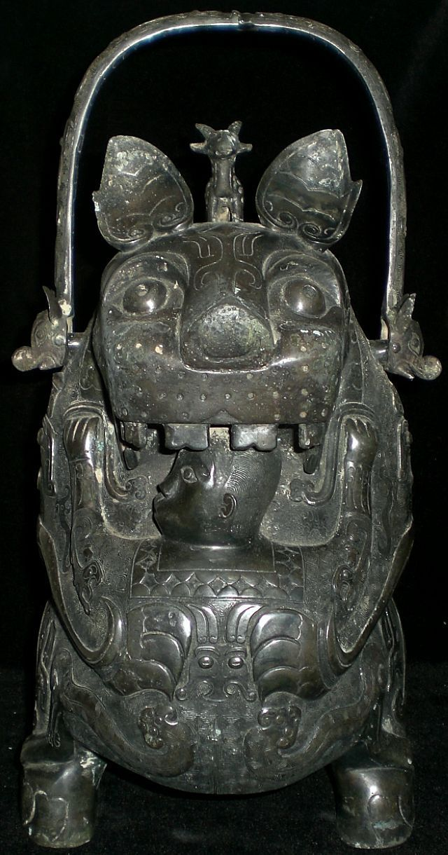

The human appears to be a male with a closely cropped hair style who is wearing a tunic with a diamond-patterned border around the neck and with a two-horned dragon design on his back.

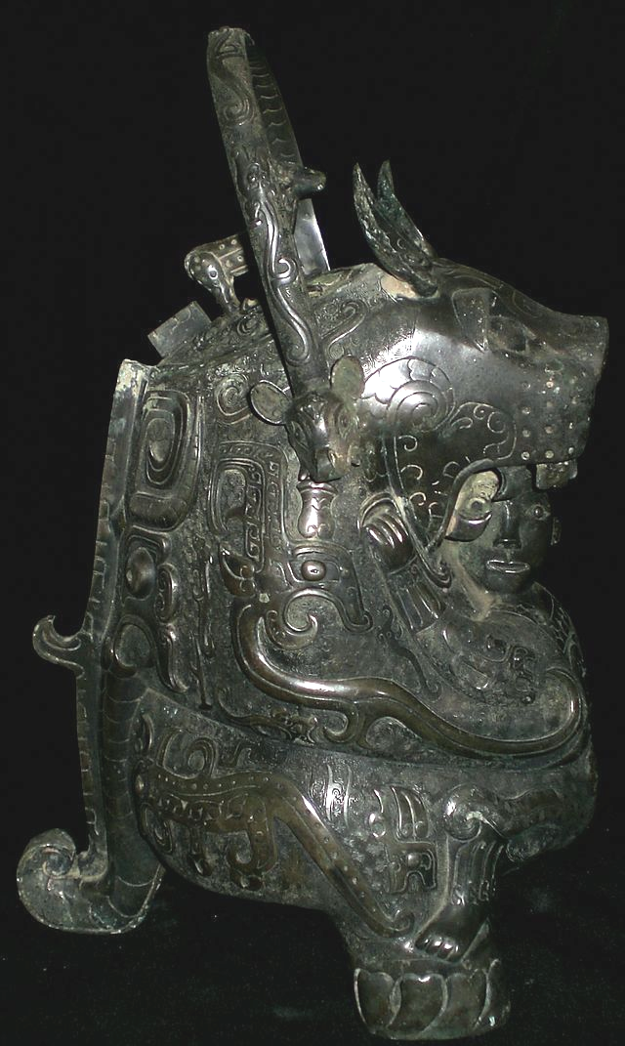

A dragon with an elaborate headdress encircles its breast as the human peers with wide-open eyes through its gaping jaws while an antelope-eared serpent with protruding wild boar tusks descends from the movable handle:

About the human's lower arms are gauntlets, much like those that protect an archer, which are repeated around his ankles as serpent's tails encircle his feet. He is wearing no shoes on his four-toed feet.

Of course, all these fantastic beings interacting with the human are metaphors for numinous powers, and primary to the images is the tiger with its gaping mouth.

One of the problems we have when trying to ascertain Shang period ideas is that except for oracle bone scripts we have very little period texts. One of the texts which is much later but which does deal with fantastic creatures and landscapes is the *Shan Hai Jing* (***Shan-hai Ching***) a compilation of early 4th century BCE fantastic geography and myth. In it we find a depiction of a shaman-like individual who is said to have contact with the numinous world of spirit powers: Pu Ting Hu Yü.

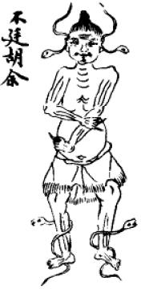

Pu Ting Hu Yü

In this depiction we see two serpents encircling his barefoot legs. Two other serpents encircle his ears. This scene, while it is 1500 years late for our purposes, does highlight two aspects of shamanic trance in China: the use of serpents and the near nakedness of the participant suggesting his ascetic qualities and his non-priestly role in society. These qualities suggest that shamanism as portrayed in the bronze tiger-man yu vessel is actually a later stage in the evolution of Chinese shamanism since the figure wears an elaborate tunic with arm and leg bands.

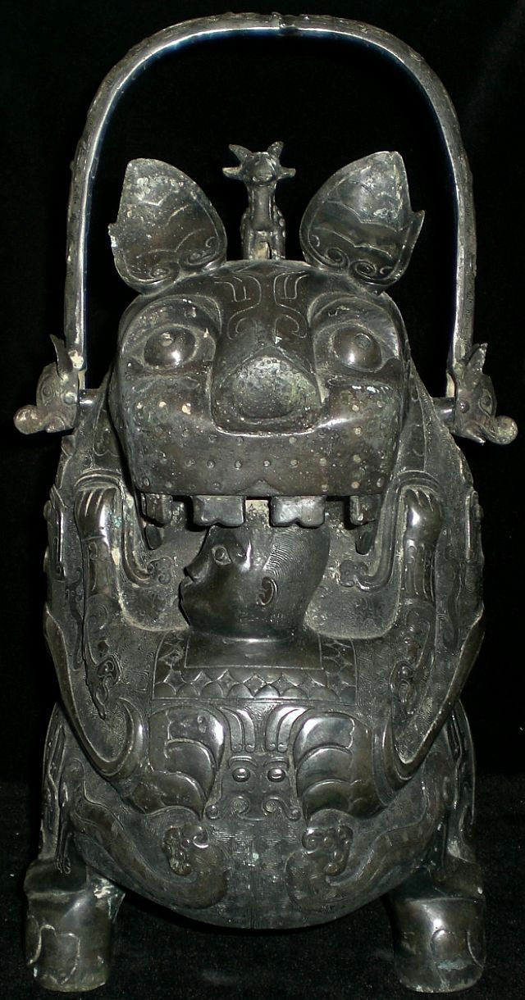

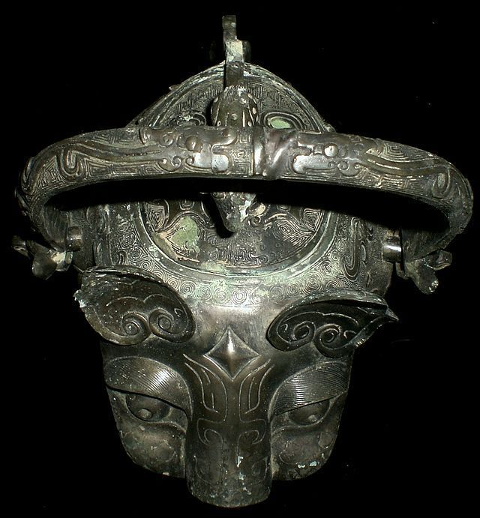 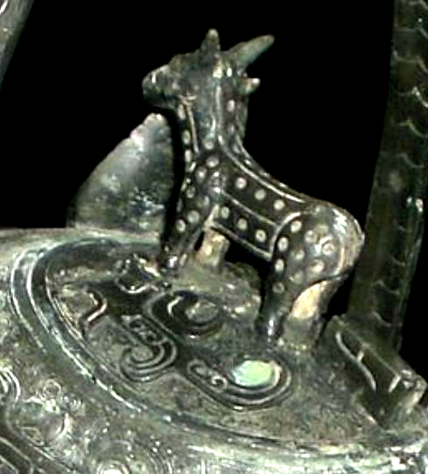  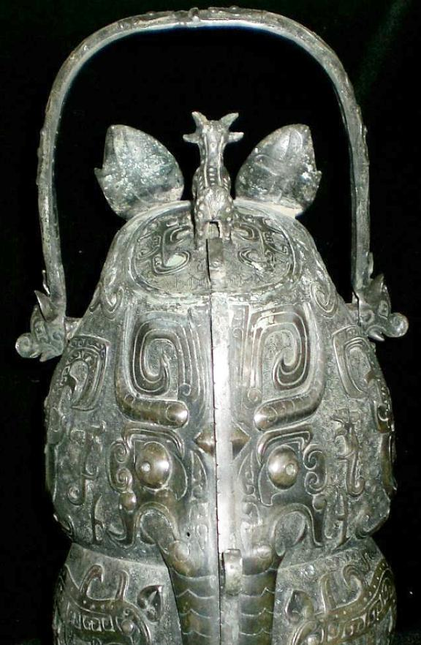 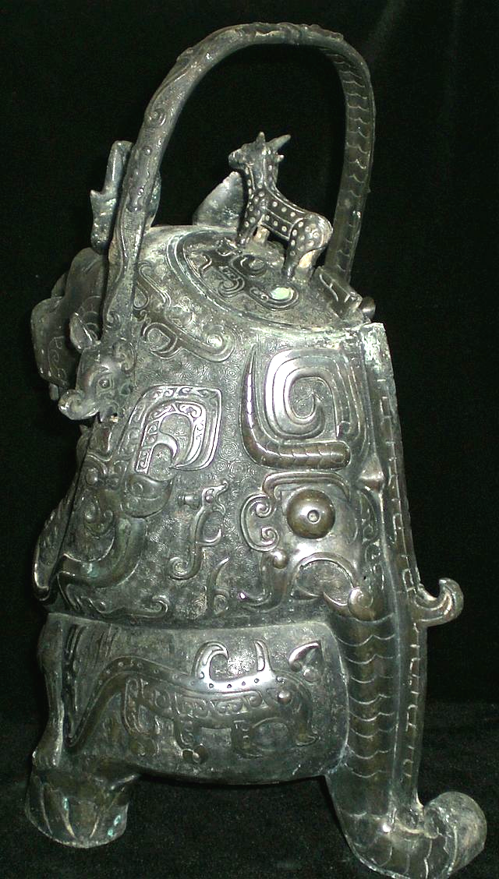

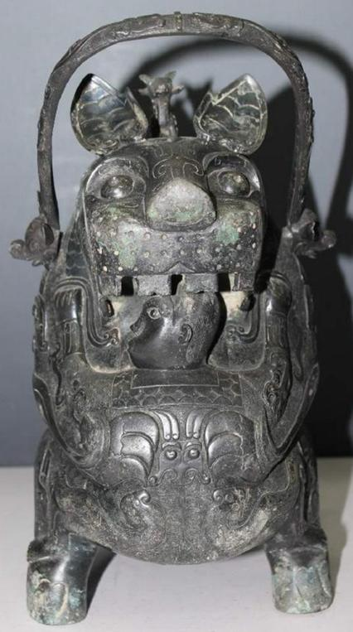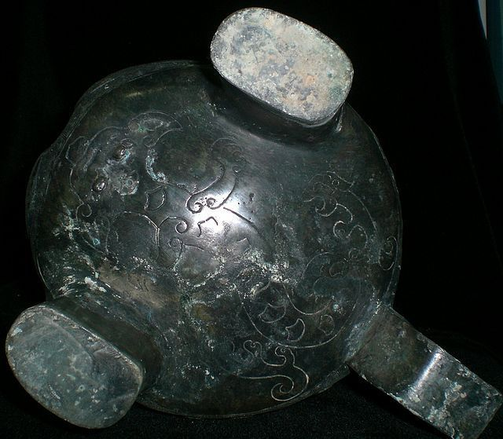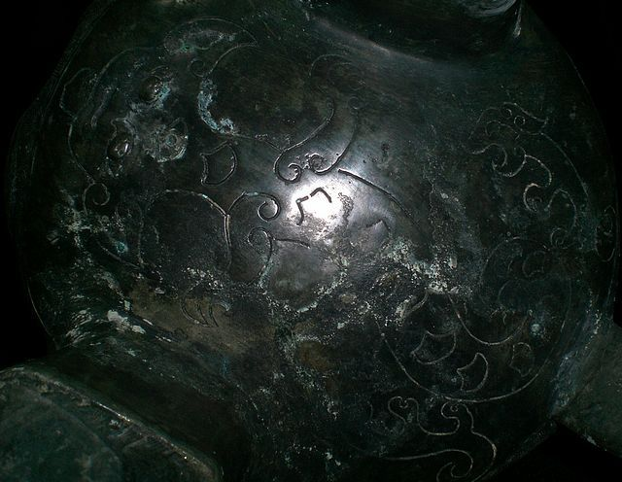

Bronze casters mark 

The tiger (hu 虎) is one of the twelve animals of the Chinese zodiac and is considered the ruler of the beasts on Earth as opposed to the dragon which rules the beasts in the sky and heavens.  
  
The tiger was perceived to be a symbol of protection: the word for tiger (hu) is also a pun because it has the same pronunciation as the word "protect" (hu 护). In ancient China, the tiger was the Guardian Spirit of Agriculture which could devour the Drought Demon.

The *you* bronze vessel called "Hushiren" ("Tiger Eats Man") is the bronze treasure of the Late Shang of China. There were two pieces found the first place, one is preserved in the museum of Japan while the other is in Paris Municipal Oriental Gallery of France. "Eating-man-tiger" reflects the myth of spirit-eating-tiger, that is, the ancients in primeval society used the brave and fierce tiger to drive away the evil spirits.   
  
Another name for this bronze vessel is *"ruhu"* - "milk-feeding tiger".   
  
It is shaped like a tigress holding a small human who is hugging a feline, while his head is placed under the mouth of the animal. The person's head is facing the tiger's wide open mouth, and it t seems that the tiger intends to eat the head of the man, but at the same time the person turns his head to one side and his face expression doesn't show any fear.   
  
The theme of a feline joined with a human figure, although present during the Shang Kingdom, is more common in the South China. It could be linked to a legend described in the Zuozhuang, an ancient commentary in the Spring and Autumn Annals (8th – 5th century B.C.) which tells the story of the grandson of Ruoao, born in the Chu Kingdom, named Ziwen who as a baby was rescued and raised by a tigress.   
  
The calm expression on the person’s face and the confident manner in which his feet rest on the feline’s paws give credit to this explanation. This legend is part of the totemic narratives that establish the origins of many aristocratic clans, bringing together man and beast in a protective relationship or through a sexual union that leads to the birth of a mythical ancestor of the Hu Kindom of the Shang Dynasty.   
  
The archaeological context behind the discovery of this piece is unknown. However, such designs were predominant features of Shang dynasty bronze art and artifacts. This artifact is complexly made which shows the excellent skill of casting art. Most of the surface patina on it. As the same as the majority of the bronze statues of late Shang, it has elaborate and complex decorations and takes the man and beast as the motif. The lower part of the *you* and the tiger's tow front paws and tail form three supporting points. There is an oval-square opening on the back of the tiger with a lid where a small dragon stands on. The prolific decoration on the dark green bronze, consisting of large animal motifs, stands out against a background of square spirals and kuilong, snakes and cloud and lightening patterns, is also characteristic of the Shang Era.   
  
What it expresses - tiger eats or feeds man - remains mystery, it's up to you to decide.  
  
Such bronze vessels served as a key instruments in aiding shamans in communicating between heaven and earth, or between ancestral spirits and other deities and living people. Symbolism and ritual status of "Tiger & Man" *you* vessel reflects the legendary powerful pantheon of ancient Chinese mythology and cosmology.

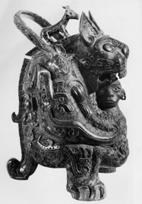

Ritual 'Yeou' vase known as 'The Tigress', detail, late Shang Dynasty, early 11th century BC (bronze) (see also 382541 and 170248)

Image ID: BCT 382542

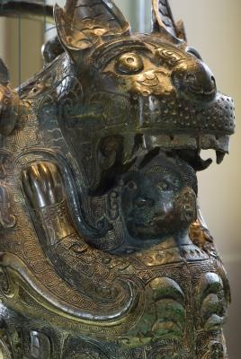

**Credit:** Ritual 'Yeou' vase known as 'The Tigress', detail, late Shang Dynasty, early 11th century BC (bronze) (see also 382541 and 170248), Chinese School, Shang Dynasty (1766-1050 BC) / Musee Cernuschi, Paris, France / Photo © Jacopo Brancati / The Bridgeman Art Library

|  |
| --- |
| BCT 382542  Image number: |
| Ritual 'Yeou' vase known as 'The Tigress', detail, late Shang Dynasty, early 11th century BC (bronze) (see also 382541 and 170248)  Title: |
| [Chinese School, Shang Dynasty (1766-1050 BC)](http://www.bridgemanart.com/search/artist/Chinese-School-Shang-Dynasty-1766-1050-BC/29483)  Primary creator: |
| Chinese  Nationality: |
| [Musee Cernuschi, Paris, France](http://www.bridgemanart.com/search/location/Musee-Cernuschi-Paris-France/3169) REFERENCESCh'en, Pang-huai (Banghuai). 1959. Jia gu wen ling shi : fu kao shi. ["Study of oracle bone inscriptions"]. Tianjin : Tianjin ren min chu ban she. 50 leaves. |

